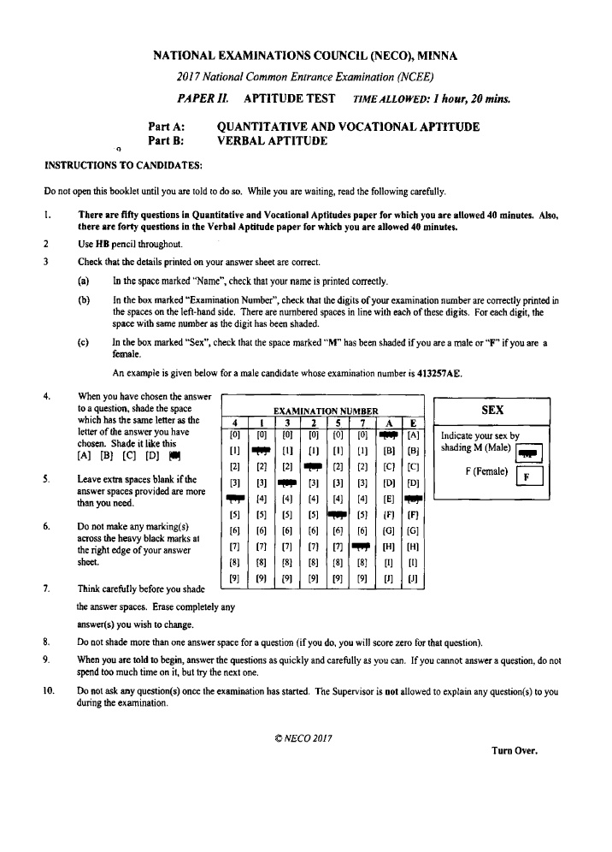
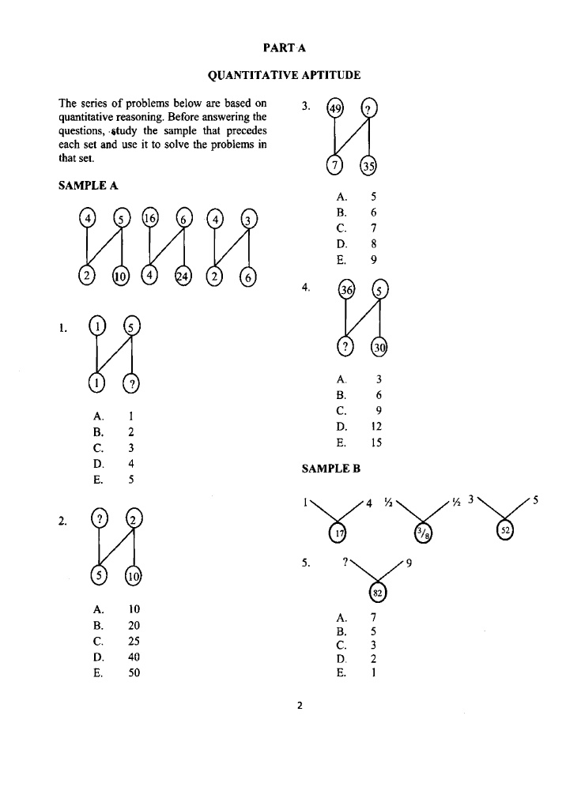
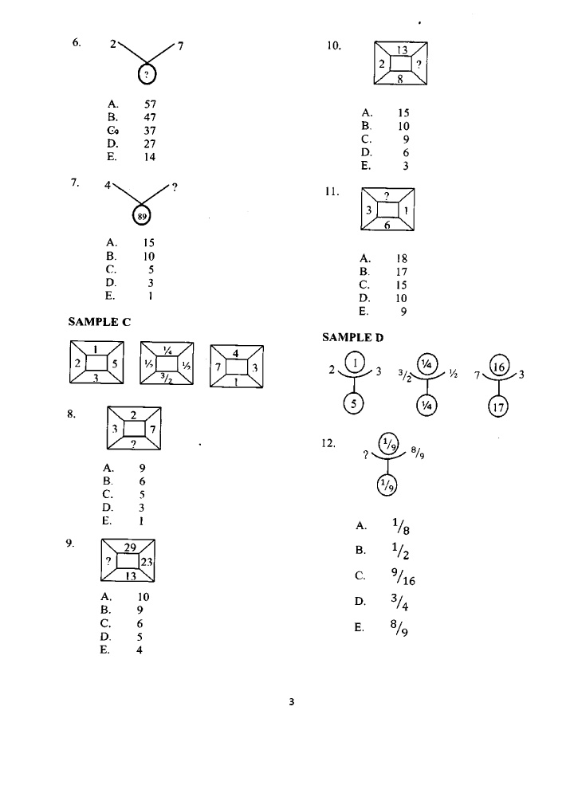
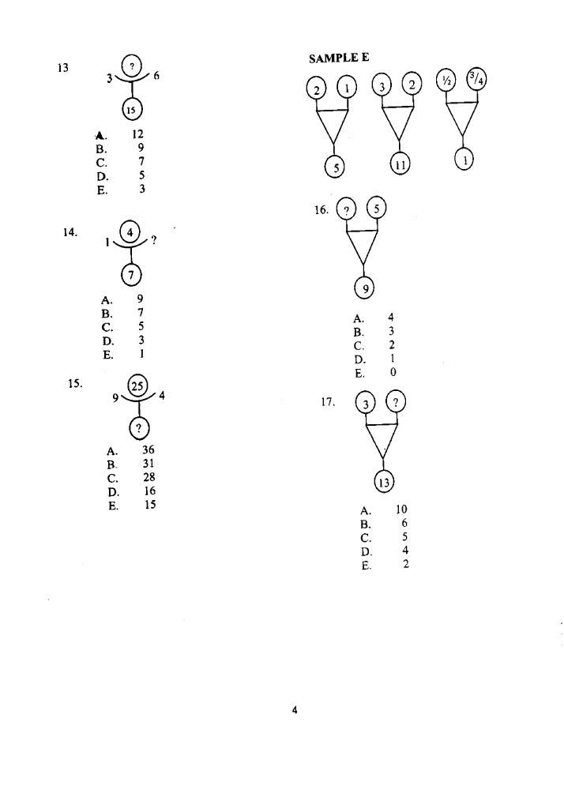

VOCATIONAL APPTITUDE
41.Which of the following is used to generate electricity in Nigeria?
- Moon (b) Sun (c) Cola (d) Hydro (e) Thermal
42. ___________ is used to make chairs. (a) Clay (b) Mud (c) Water (d) Raffia . Palm (e) Wood
- Which of the following is not required for a vocation.
- Capital (b) Labour (c) Raw materials (d) Tools (c) University Education
- Which of the following is used in making ceramics?
- Clay (b) Wood (c) Glass (d) Stone (e) Rubber
- The different grades of oil can be identified by ____________.
- Density (b) Fluidity (c) Gravity (d) Humidity (c) Viscosity
- Which of these towns in Nigeria has more industries than others ___________.
- Abeokuta (b) Lagos (c) Kastina (d) Maiduguri (e) Benin

- Which of the following Vocation is NOT associated with the diagram above.
- Catering (b) Painters (c) Plumbers (d) Bricklayers (e) Carpenters
- Which of the following tools is used by a Fisherman?
- Brush (b) Plier (c) Saw (d) Net (e) Shear
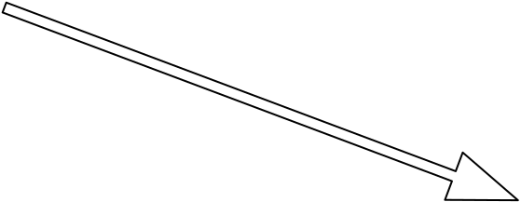
- The object below is used for ____________
- Carving (b) Farming (c) Mining (d) Painting (e) Hunting
- The __________________ is a place where clothes are washed.
- Stadium (b) Laundry (c) Cemetery (d) Laundry (e) Dormitory

